# **1. INTRODUCTION**

Solar flare, sudden intense brightening in the solar corona, usually in the vicinity of a magnetic inversion near a sunspot group. The flare develops in a few minutes, or even seconds, and may last several hours. High-energy particles, electron streams, hard X-rays, and radio bursts are often emitted, and a shock wave occurs when the flare interacts with the interplanetary medium. The flare occurs above the surface in the corona, and energy deposited in the surface brings up a superhot cloud, about 100 million Kelvins (100 million °C, or 180 million °F), which is a strong, long-lasting source of X-rays. Smaller flares do not show all these attributes, and flares rarely occur in the three or four years of sunspot minimum. The biggest flares occur in association with large sunspots that have sharp magnetic gradients and large currents, which are the source of the flare energy. There is a class of spotless flares associated with filament eruptions; they are large and sometimes produce coronal mass ejections but produce few high-energy particles.

There exists a thin line of difference between solar flares and coronal mass ejections. Although both are gigantic explosions of high energy particles in the sun, they are different altogether. Coronal mass ejections (CMEs) are large clouds of solar plasma and embedded magnetic fields released into space and often expand to spread across millions of miles as they move through space while solar flares are energetic bursts of light and particles triggered by the release of magnetic energy on the sun.

EarthSky, E. of. (2023a, March 22). *Is a solar flare the same thing as a CME?* https://earthsky.org/sun/is-a-solar-flare-the-same-thing-as-a-cme/

**1.1 Motivation**

The motivation behind developing prediction models for solar flares stems from the potential impact of these solar events on various aspects of modern technological infrastructure and scientific understanding. Solar flares are sudden and intense releases of energy on the Sun's surface, accompanied by bursts of electromagnetic radiation.

The motivation can be summed up by the following points:

Space Weather Impact on Technology: Solar flares can release high-energy particles and intense bursts of radiation that can affect Earth's upper atmosphere. This space weather phenomenon can interfere with satellite communications, disrupt navigation systems, and pose a threat to power grids and other technological infrastructure. Predicting solar flares enables us to take preventive measures and implement safeguards to mitigate potential damage to these systems.

Astronaut Safety: For manned space missions, such as those conducted by space agencies like NASA, solar flares pose a significant risk to astronaut safety. The intense radiation associated with solar flares can be harmful to human health. Predictive models allow mission planners to schedule spacewalks and other activities during periods of lower solar activity, reducing the risk to astronauts.

Understanding Solar Dynamics: Solar flares are complex phenomena influenced by the Sun's magnetic activity. Developing prediction models contributes to a better understanding of solar dynamics and helps researchers identify patterns and trends in solar activity. This, in turn, enhances our knowledge of fundamental solar processes and contributes to advancements in solar physics.

Early Warning Systems: Prediction models provide the basis for developing early warning systems for solar flares. Timely alerts can be crucial for space agencies, satellite operators, and other stakeholders to take precautionary measures and safeguard their assets in space. This includes temporarily shutting down sensitive electronic systems on satellites and spacecraft.

Scientific Research: Solar flares offer a unique opportunity to study extreme astrophysical phenomena. Predictive models assist astronomers and researchers in planning observations and experiments, allowing them to capture valuable data during solar flare events. This data contributes to a deeper understanding of the Sun's behavior and its impact on the solar system.

**1.2 Objective**

The objectives aimed to achieve from this project are defined as follows:

(i) To develop prediction models that enable the implementation of measures to protect critical infrastructure, thereby reducing the likelihood of disruptions caused by solar-induced geomagnetic activity.

(ii) The development of accurate prediction models aim to enhance space weather forecasting capabilities. This includes forecasting the intensity, timing, duration and location of solar flare events. Improved forecasting allows for better preparation, giving space agencies, satellite operators, and other stakeholders the information needed to make informed decisions and take timely actions.

(iii) The primary objective is to establish effective early warning systems for solar flares. Early detection and prediction allow for the issuance of timely alerts to space agencies, satellite operators, and other relevant entities, enabling them to take proactive measures to safeguard assets and systems in space and on Earth.

Prediction models create opportunities for scientists and researchers to conduct targeted observations and experiments during anticipated solar flare events. This objective aims to gather valuable data that contributes to a broader understanding of solar phenomena, advancing scientific knowledge and exploration of the Sun.

**2. Existing Work / Literature Review**

According to various existing works, multiple models and approaches have been used for predicting solar flares among those listed below:

# **1) Statistical Models:**

# Historical Patterns: Statistical models analyze historical data to identify patterns and trends that precede solar flares. These models often use time series analysis to detect changes in solar activity leading up to flares.

# **2) Machine Learning Models:**

# Neural Networks: Artificial neural networks, including deep learning architectures, have been applied to solar flare prediction. These models can learn complex relationships between various solar parameters and the occurrence of flares.

# Support Vector Machines (SVM): SVM is a supervised learning algorithm that has been used for solar flare prediction by classifying solar features based on historical data.

# Random Forests: Ensemble methods like random forests have been employed to combine the predictions of multiple decision trees, improving overall prediction accuracy.

# **3) Physics-Based Models:**

# Magnetohydrodynamic (MHD) Models: These models simulate the behavior of the solar atmosphere using principles of magnetohydrodynamics. They take into account the magnetic field, plasma dynamics, and other physical parameters to predict solar flares.

# Flux Rope Models: Flux ropes are structures in the solar atmosphere believed to be associated with solar flares. Models based on the evolution of flux ropes aim to predict flares by monitoring the development of these structures.

# 

# **4) Hybrid Models:**

# Combination of Statistical and Physics-Based Approaches: Some models integrate statistical techniques with physics-based simulations to leverage the strengths of both approaches. This hybridization aims to improve the accuracy and reliability of solar flare predictions.

# **5) Data-Driven Approaches:**

# Feature Engineering: Identifying relevant features or parameters from observational data is crucial for building accurate prediction models. Researchers often use feature engineering to select the most informative variables.

# Data Mining Techniques: Data mining methods are employed to extract patterns and knowledge from large datasets, helping to identify key indicators of solar flare activity.

# **6) Real-Time Monitoring Systems:**

# Some models are designed to provide real-time monitoring of solar activity, enabling timely alerts and warnings for space weather events. These systems are crucial for mitigating potential impacts on satellite operations, communication systems, and power grids on Earth.

# 

# **3. Topic of the work**

# This project is divided into 2 halves -

1. Prediction Model
2. Effects of the predicted Solar Flare on Earth’s Magnetic Field

**3.1 THE PREDICTION MODEL:**

# The prediction model is the brain of the project. In brief, the model’s function is to capture data and analyze it to make predictions on the intensity of the solar flare through their geomagnetic interaction.

# A high-level architecture for a solar flare prediction model is as follows:

# **.** Data Collection:

# Solar Observations: Collect real-time solar observations, including data from solar satellites and ground-based observatories. This data may include images, magnetic field measurements, and other relevant parameters.

# **.** Preprocessing:

# Data Cleaning and Formatting: Prepare the collected data by cleaning and formatting it for further analysis.

# **.** Feature Extraction: Extract relevant features from the raw data. This may involve time series analysis, image processing, and identifying key parameters associated with solar flares.

# 

# **.** Data Integration:

# Combine Multiple Data Sources: Integrate data from various sources, such as solar imagery, magnetograms, and other relevant space weather data, to create a comprehensive dataset.

# **.** Feature Selection:

# Identify Important Features: Use feature selection techniques to identify the most important parameters that contribute to solar flare prediction. This step helps reduce dimensionality and enhance model interpretability.

# 

# **.** Model Selection:

# Machine Learning Models: Choose appropriate machine learning models based on the nature of the problem. Neural networks, support vector machines, and ensemble methods are common choices for solar flare prediction.

**.** Training:

Historical Data: Train the selected model using historical data on solar flares. This involves splitting the dataset into training and validation sets to ensure the model's generalization to unseen data.

**.** Validation and Hyperparameter Tuning:

Cross-Validation: Validate the model's performance using cross-validation techniques to assess its robustness.

Hyperparameter Tuning: Fine-tune the model's hyperparameters to optimize its predictive capabilities.

**.** Real-Time Prediction:

Deployment: Deploy the trained model in a real-time environment to monitor solar activity continuously.

Integration with Space Weather Centers: Collaborate with space weather monitoring centers to integrate the model into their systems for timely alerts and warnings.

**.** Monitoring and Updating:

Continuous Monitoring: Implement a system for continuous monitoring of the model's performance and recalibration as needed.

Model Updating: Periodically update the model with new data to ensure its relevance and effectiveness over time

(Author links open overlay panelF. Ribeiro et al., 2021)

Here are the screenshots of the unclean and cleaned data :-

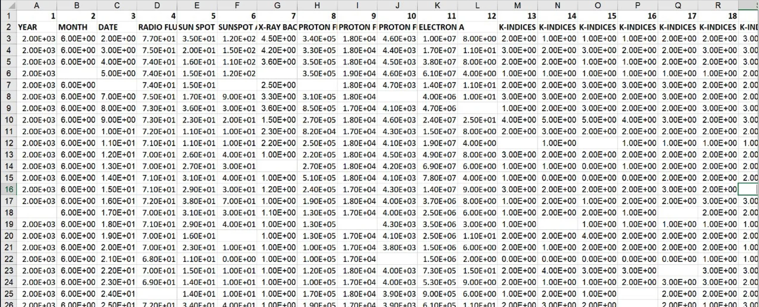

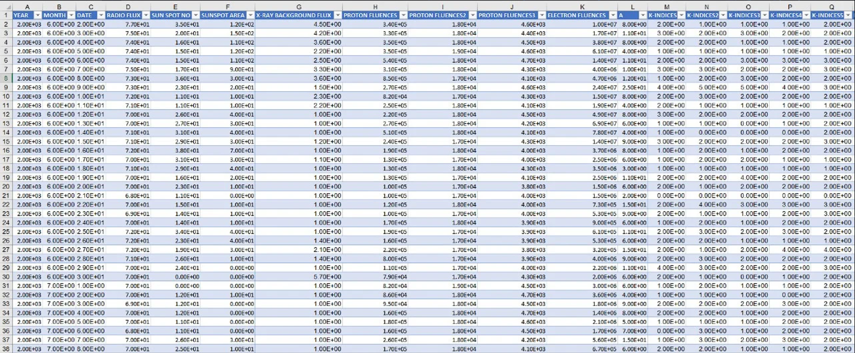

Code and their output:

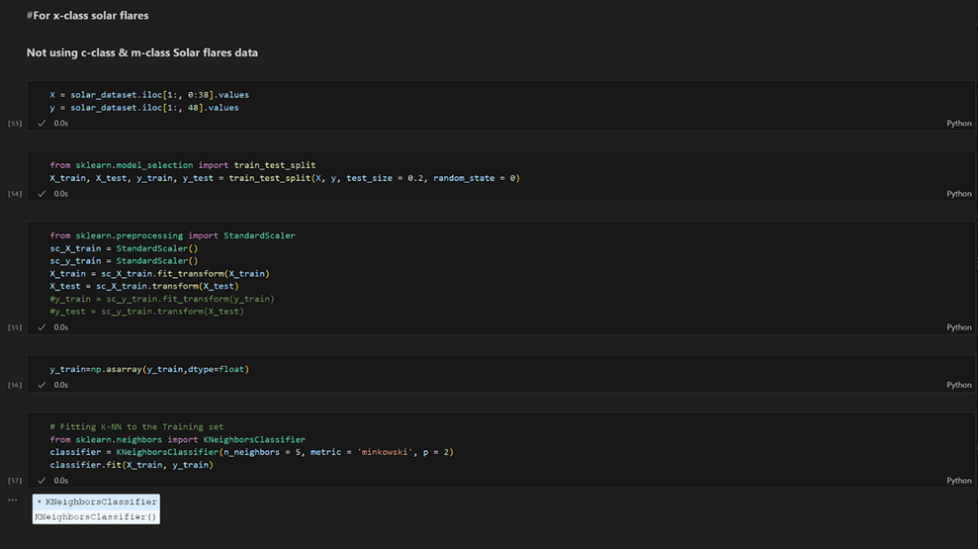

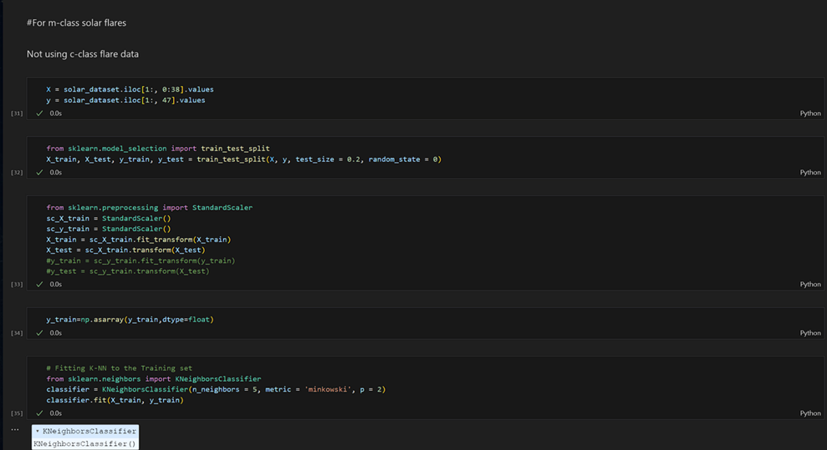

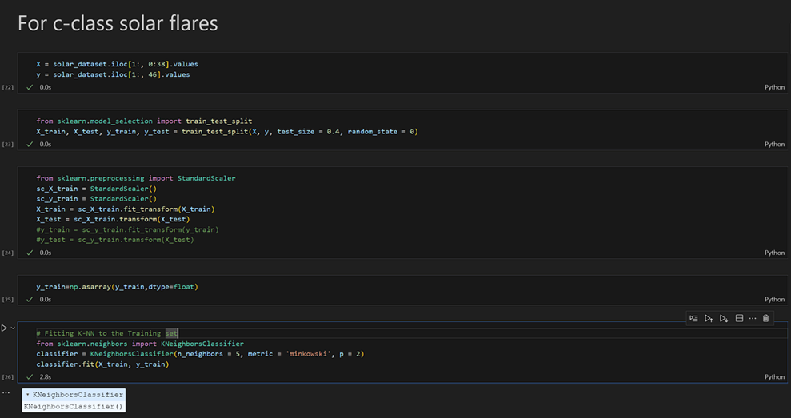

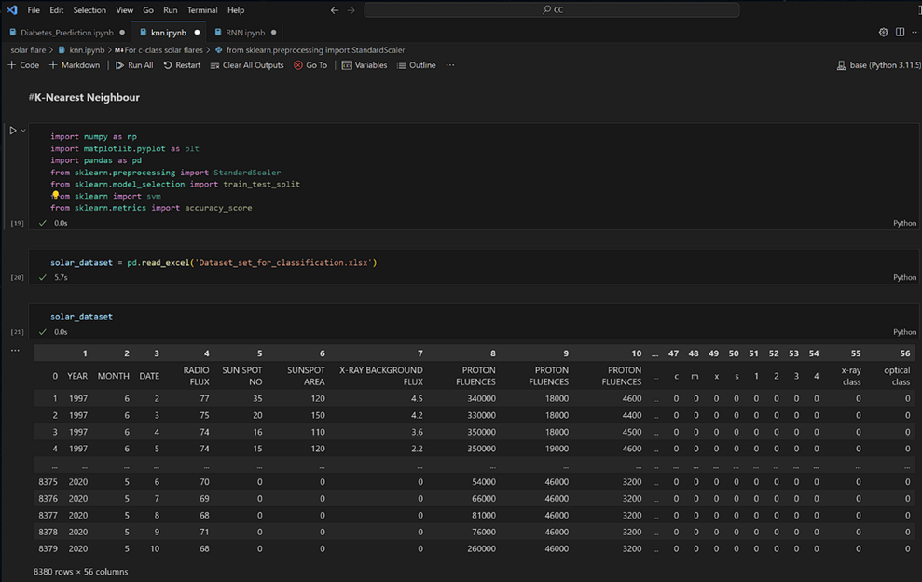

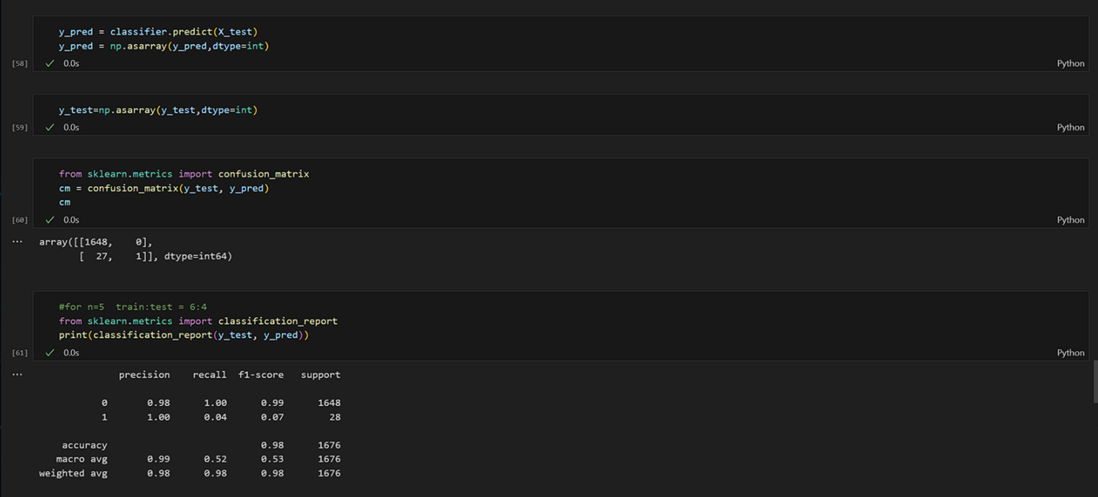

**3.2 ANALYSIS OF EFFECTS:**

Herein, we delve into the intricate interplay between solar phenomena and terrestrial magnetism, striving to unravel the complexities underlying space weather dynamics. Our approach encompasses the development of a robust mathematical model tailored to simulate the behavior of Earth's geomagnetic field in response to solar activity. This model, underpinned by a rich dataset, incorporates a myriad of mathematical expressions to encapsulate the multifaceted interactions between solar emissions and terrestrial magnetism.

Through meticulous calibration and validation against observational data, our mathematical model emerges as a potent tool for elucidating the effects of solar flares on Earth's geomagnetic field. We scrutinize various parameters, ranging from solar flare intensity and duration to geomagnetic storm severity, to discern intricate causal relationships and emergent phenomena. By elucidating the mechanisms driving geomagnetic disturbances, such as magnetic reconnection and ionospheric coupling, our analysis offers profound insights into the dynamics of space weather phenomena.

Moreover, our study extends beyond mere theoretical exploration, aiming to inform practical considerations and real-world applications. By elucidating the potential impacts of solar flares on terrestrial infrastructure, such as power grids and communication networks, our analysis empowers stakeholders to devise robust mitigation strategies and enhance operational resilience. Additionally, our findings hold implications for space exploration endeavors, guiding mission planning and spacecraft design to withstand the rigors of space weather.

**4. MATHEMATICAL MODEL AND APPROACH:**

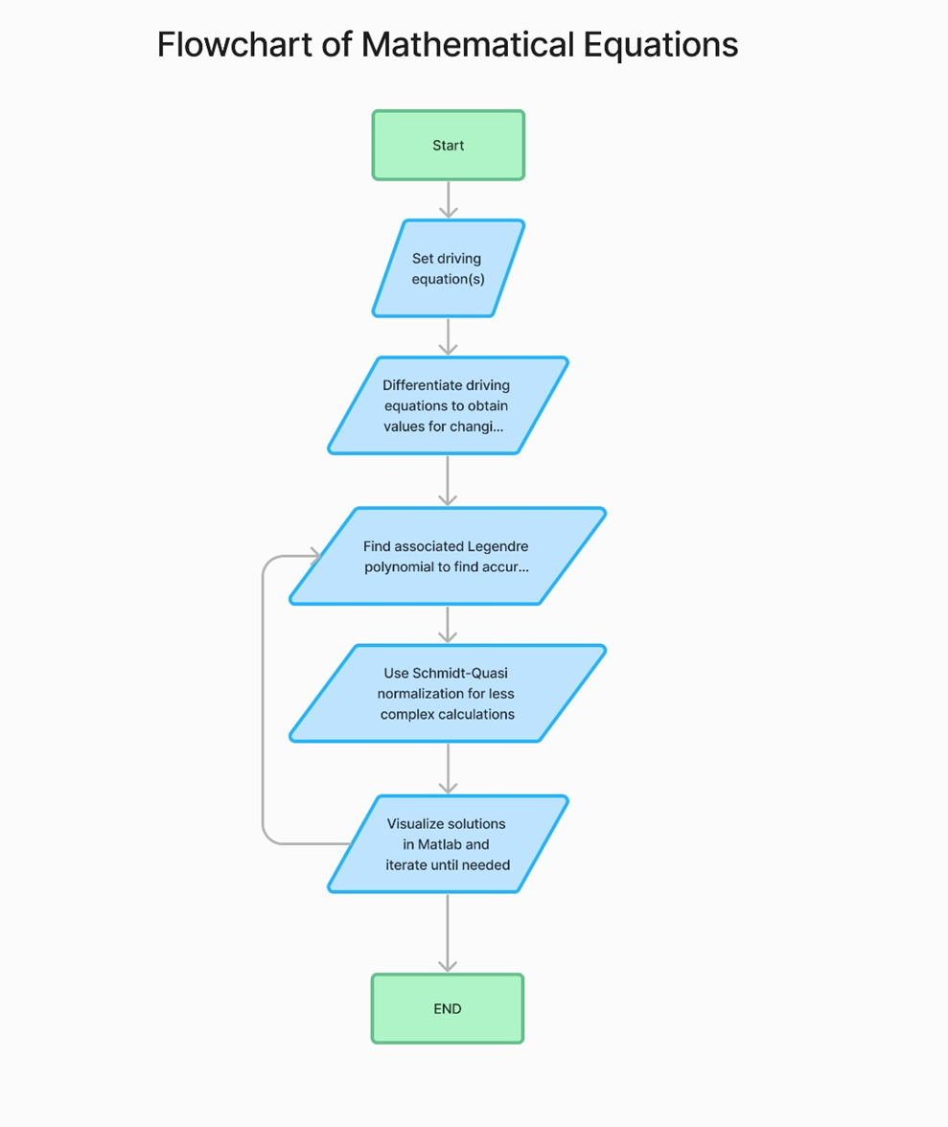

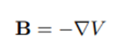

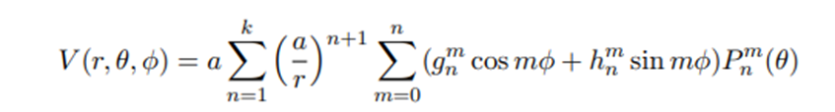

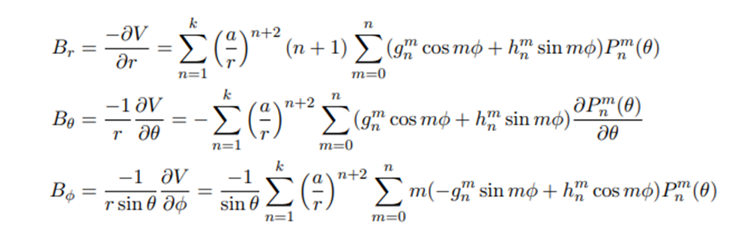

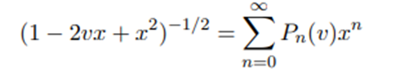

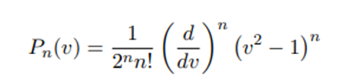

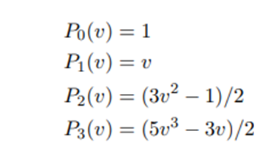

Schaub, H. (2004, May 12). *Mathematical modeling of Earth’s magnetic field*. Geomagnetic Field. https://hanspeterschaub.info/Papers/UnderGradStudents/MagneticField.pdf

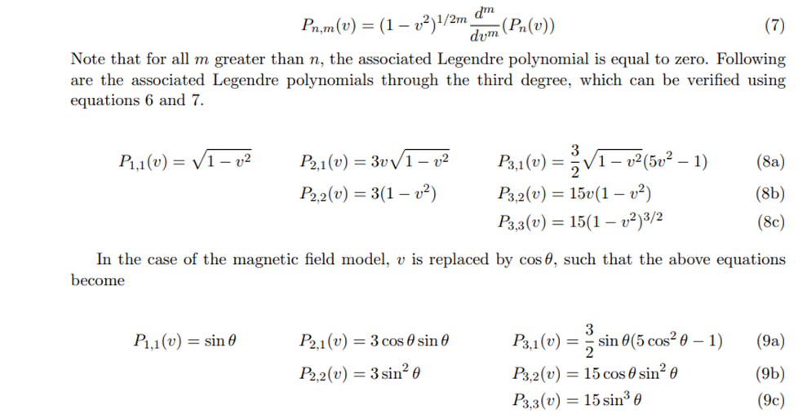

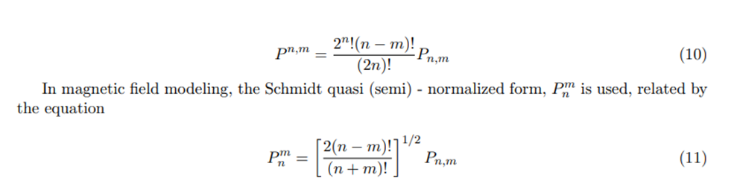

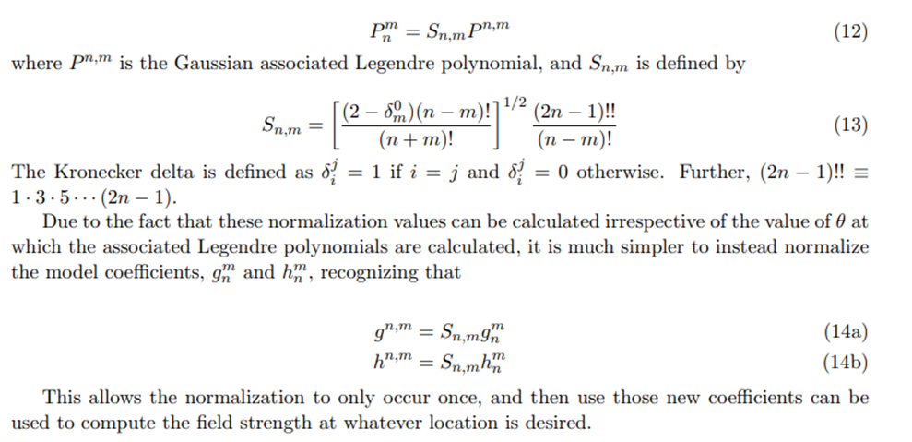

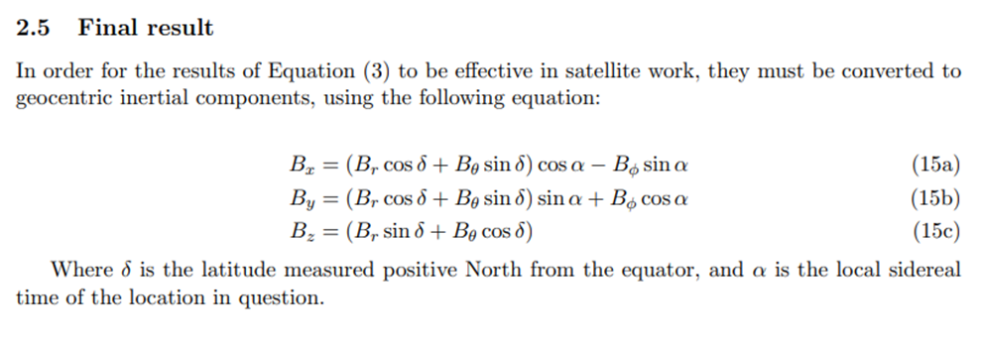

Edu, H. (2005). *Geomagnetism and Schmidt quasi-normalization*. 2005geoji.160..487W Page 487. https://adsabs.harvard.edu/full/2005GeoJI.160..487W

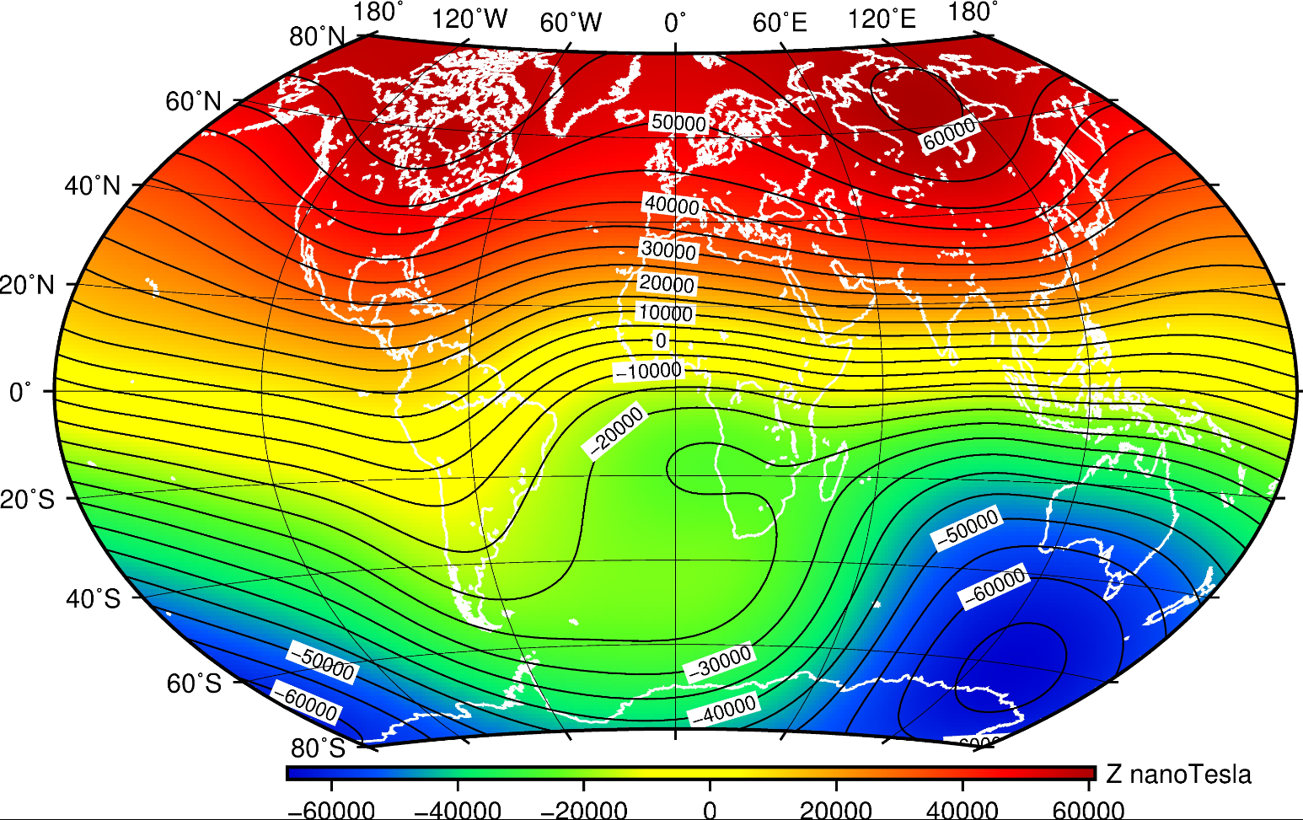

DeRosa, M. L. (2008). IOPscience. https://iopscience.iop.org/

The coefficients used in the above equations are obtained through an already existing table of values as established by the IGRF.

The International Geomagnetic Reference Field (IGRF) is a mathematical model that describes the Earth's main magnetic field and its secular variations over time. It is developed and maintained by the International Association of Geomagnetism and Aeronomy (IAGA) through the Working Group V-MOD (Geomagnetic Field Modeling).

The IGRF provides a standardized and accurate representation of the Earth's magnetic field at the Earth's surface and extends into the Earth's interior. The model is based on a combination of observational data from ground-based and satellite measurements and mathematical representations, particularly a spherical harmonic model of the geomagnetic scalar potential. (American Astronomical Society, 2004)

Key characteristics of the IGRF include:

1. **Global Representation:** The IGRF provides a global model of the Earth's magnetic field, taking into account variations in intensity, inclination, and declination at different locations.
2. **Reference for Magnetic Navigation:** The IGRF is essential for navigation systems, including those used in aircraft, ships, and other vehicles, which rely on accurate information about the Earth's magnetic field for navigation.
3. **Scientific Research:** Scientists use the IGRF for various geophysical and space weather studies, including understanding the Earth's interior, studying geomagnetic secular variation, and investigating interactions with the solar wind.
4. **Regular Updates**: The IGRF is updated periodically to account for changes in the Earth's magnetic field. The updates are typically released every five years, incorporating new data and advancements in geomagnetic field modeling techniques.

All the above equations are used to make the model using *MATLAB*. However, datasets were collected from the *NOAA* website in order to execute the code. The data found was in a text file and was *Clean, but Non – Normalised*. Hence, the first step was to normalize the data.

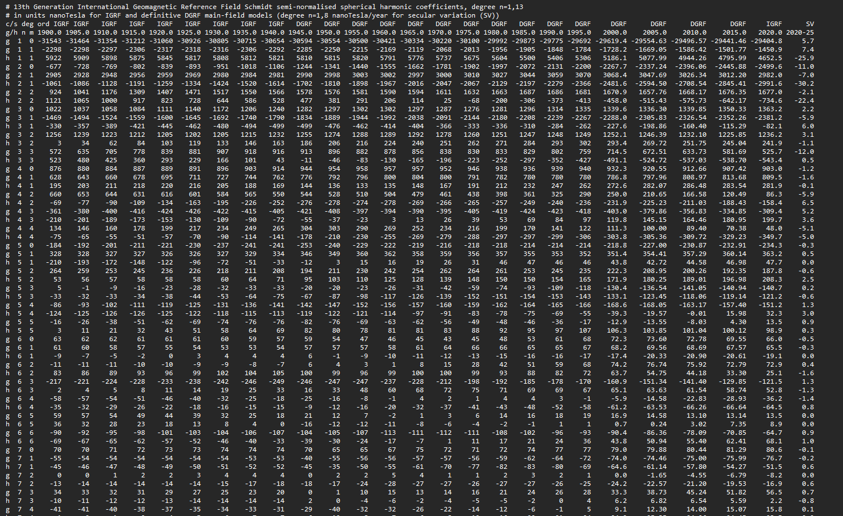

*Schmidt-Quasi normalization* technique is implemented on the datasets to account for variations and standardize the data for accurate mathematical modeling.

*Geomagnetism and Schmidt quasi-normalization | OUP Journals & Magazine | IEEE Xplore*. Schmidt Quasi Normalization. (2013). https://ieeexplore.ieee.org/document/8141160

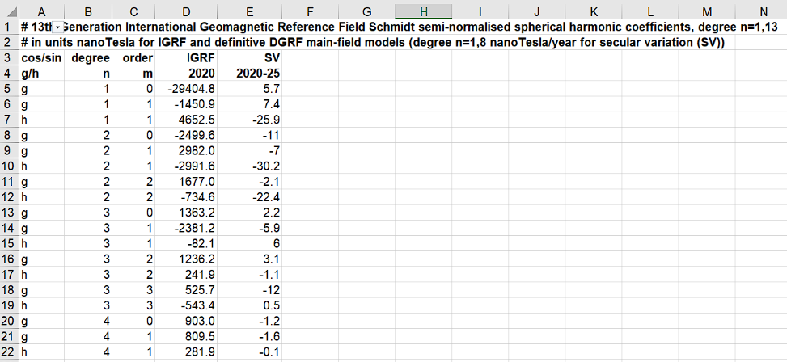

All the above, including all the equations, expressions, data is visualized and calculated using Matlab.

# 

# **MATLAB CODE:**

# **Converting from spherical to Cartesian coordinates**

# function [X,Y,Z] = msph2cart(Br,Bt,Bp)

# % Inputs - magnetic field strength (B) in local tangential coordinates

# % Br B in radial direction

# % Bt B in theta direction

# % Bp B in phi direction

# % Outputs - magnetic field strength (B) in local tangential coordinates

# % X B in "north" direction

# % Y B in "east" direction

# % Z B in down direction

# % Variables

# % e epsilon, the term used to correct for the oblateness of the

# % Earth. In all programs online, e=0

# e = 0.0*pi/180;

# X = -Bt*cos(e) - Br*sin(e);

# Y = Bp;

# Z = Bt*sin(e) - Br*cos(e);

# A.2.2 msph2inert.m - converting from tangential spherical to geocentric inertial

# Cartesian coordinates

# function [Bx,By,Bz] = msph2inert(Br,Bt,Bp,LST,lat)

# % Inputs

# % Br B in radial direction | Magnetic field strength (B)

# % Bt B in theta direction | in local tangential coordinates

# % Bp B in phi direction |

# % LST Local sidereal time of location (in degrees)

# % lat Latitude measured positive north from equator (in degrees)

# % Outputs

# % Bx B in x-direction | Magnetic field strength (B)

# % By B in y-direction | in geocentric inertial coordinates

# % Bz B in z-direction |

# % Angle conversion to radians

# lat=lat*pi/180; LST=LST*pi/180;

# % Coordinate transformation

# Bx = (Br*cos(lat)+Bt*sin(lat))*cos(LST) - Bp*sin(LST);

# By = (Br*cos(lat)+Bt*sin(lat))*sin(LST) + Bp*cos(LST);

# Bz = (Br*sin(lat)+Bt*cos(lat));

# 2) A.1 magnet.m - calculates magnetic field strength in local spherical coordinates

# 

# function [Br,Bt,Bp] = magnet(r,theta,phi,days)

# % Inputs

# % r Geocentric radius

# % theta Latitude measured in degrees positive from equator

# % phi Longitude measured in degrees positive east from Greenwich

# % days Decimal days since January 1, 2000

# %

# % Outputs - magnetic field strength in local tangential coordinates

# % Br B in radial direction

# % Bt B in theta direction

# % Bp B in phi direction

# % Checks to see if located at either pole to avoid singularities

# if (theta>-0.00000001 & theta<0.00000001)

# theta=0.00000001;

# elseif(theta<180.00000001 & theta>179.99999999)

# theta=179.99999999;

# end

# % The angles must be converted from degrees into radians

# theta=(90-theta)*pi/180;

# phi = phi*pi/180;

# a=6371.2; % Reference radius used in IGRF

# % This section of the code simply reads in the g and h Schmidt

# % quasi-normalized coefficients

# [gn, gm, gvali, gsvi] = textread(’igrfSg.txt’,’%f %f %f %f’);

# [hn, hm, hvali, hsvi] = textread(’igrfSh.txt’,’%f %f %f %f’);

# N=max(gn);

# g=zeros(N,N+1);

# h=zeros(N,N+1);

# for x=1:length(gn)

# g(gn(x),gm(x)+1) = gvali(x) + gsvi(x)*days/365;

# h(hn(x),hm(x)+1) = hvali(x) + hsvi(x)*days/365;

# end

# % Initialize each of the variables

# % Br B in the radial driection

# % Bt B in the theta direction

# 12

# % Bp B in the phi direction

# % P The associated Legendre polynomial evaluated at cos(theta)

# % The nomenclature for the recursive values generally follows

# % the form P10 = P(n-1,m-0)

# % dP The partial derivative of P with respect to theta

# Br=0; Bt=0; Bp=0;

# P11=1; P10=P11;

# dP11=0; dP10=dP11;

# for m=0:N

# for n=1:N

# if m<=n

# % Calculate Legendre polynomials and derivatives recursively

# if n==m

# P2 = sin(theta)*P11;

# dP2 = sin(theta)*dP11 + cos(theta)*P11;

# P11=P2; P10=P11; P20=0;

# dP11=dP2; dP10=dP11; dP20=0;

# elseif n==1

# P2 = cos(theta)*P10;

# dP2 = cos(theta)*dP10 - sin(theta)*P10;

# P20=P10; P10=P2;

# dP20=dP10; dP10=dP2;

# else

# K = ((n-1)^2-m^2)/((2*n-1)*(2*n-3));

# P2 = cos(theta)*P10 - K*P20;

# 

# 

# **Visualization of the Output and Final Result**

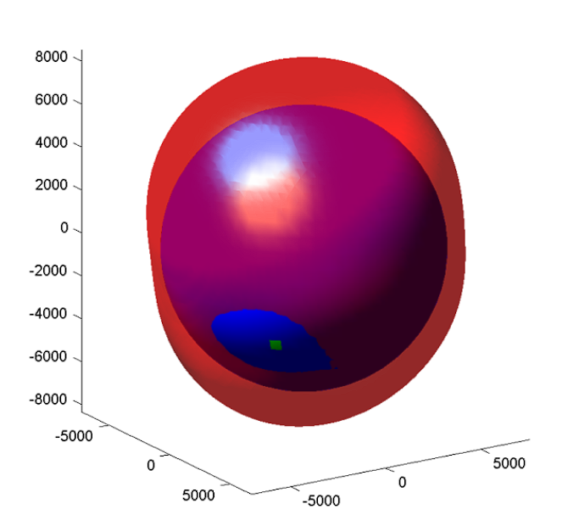

Schaub, H. (2004, May 12). *Mathematical modeling of Earth’s magnetic field*. Geomagnetic Field. https://hanspeterschaub.info/Papers/UnderGradStudents/MagneticField.pdf

# 

# 

# 

# 

# **4. CONCLUSION:**

As we conclude our journey of collecting sample data, we stand at the threshold of a promising venture in developing a Solar Flares Prediction Model. Our dedicated efforts in gathering this foundational data mark the inception of a groundbreaking initiative with profound implications for space weather forecasting.

The primary goals behind the Solar Flares Prediction Model encompass a dual purpose: first, to enhance our predictive capabilities in anticipating solar flares with greater precision, and secondly, to mitigate the potential risks and implications associated with these solar eruptions. By harnessing the power of data analysis, machine learning, and predictive modeling, our aim is to unravel the intricate patterns inherent in solar activity, enabling us to foresee and prepare for these phenomena more effectively.

In conclusion, our foray into collecting sample data represents the initial strides toward a more resilient future in understanding and predicting solar flares. The fruition of this model holds the promise of not only advancing our scientific understanding but also fortifying our preparedness against the ever-evolving dynamics of space weather, thereby shaping a more secure technological landscape for generations to come.

# 

# **5. BIBLIOGRAPHY:**

1. **https://hanspeterschaub.info/Papers/UnderGradStudents/MagneticField.pdf**
2. **Edu, H. (2005). *Geomagnetism and Schmidt quasi-normalization*. 2005geoji.160..487W Page 487. https://adsabs.harvard.edu/full/2005GeoJI.160..487W**
3. **Schaub, H. (2004, May 12). *Mathematical modeling of Earth’s magnetic field*. Geomagnetic Field. https://hanspeterschaub.info/Papers/UnderGradStudents/MagneticField.pdf**
4. ***Geomagnetism and Schmidt quasi-normalization | OUP Journals & Magazine | IEEE Xplore*. Schmidt Quasi Normalization. (2013).**
5. **https://github.com/Aman-95/Solar-flare-prediction-using-Machine-learning-and-4**
6. **Neural-Networks/blob/main/Project%20Report.pdf**
7. **https://ieeexplore.ieee.org/document/8141160 EarthSky, E. of. (2023a, March 22). *Is a solar flare the same thing as a CME?* https://earthsky.org/sun/is-a-solar-flare-the-same-thing-as-a-cme/**
8. **Shepherd, S. G. (1998). *Ionospheric structure and the generation of auroral roar - shepherd ...https://agupubs.onlinelibrary.wiley.com/doi/10.1029/98ja02295*. Ionospheric structure. https://agupubs.onlinelibrary.wiley.com/doi/10.1029/98JA02295 Wheatland, M. S. (2006a). *The state of Nonlinear Force-free magnetic field*. The state of nonlinear force-free magnetic field extrapolation. https://iopscience.iop.org/article/10.1088/1742-6596/440/1/012037/pdf**
9. ***Nonlinear force-free modeling of coronal magnetic fields ...* Force-Free Modeling. (2017). http://www2.mps.mpg.de/homes/wiegelmann/nlfff1.pdf**
10. **Sawyer, C. (1986). Solar Flare Prediction. https://apps.dtic.mil/sti/citations/ADA166547**
11. **https://iopscience.iop.org/article/10.1086/527413/pdf**
12. **NONLINEAR FORCE-FREE MODELING OF CORONAL MAGNETIC FIELDS PART I: A QUANTITATIVE COMPARISON OF METHODS**
13. **Nishizuka, N., Kubo, Y., Sugiura, K., Den, M., & Ishii, M. (2021, March 5). *Operational solar flare prediction model using Deep flare net - earth, planets and space*. SpringerOpen. https://earth-planets-space.springeropen.com/articles/10.1186/s40623-021-01381-9**
14. **Agarwaltanmay. (n.d.). *Agarwaltanmay/prediction: Predicting solar generation based on weather forecast - a project which was part of Machine Learning Course at BITS Pilani*. GitHub. https://github.com/agarwaltanmay/prediction**
15. **Chen, Y., Maloney, S., Camporeale, E., Huang, X., & Zhou, Z. (2023, March 1). *Editorial: Machine learning and statistical methods for solar flare prediction*. Frontiers. https://www.frontiersin.org/articles/10.3389/fspas.2023.1121615/full**
16. **Solar flare prediction using advanced feature extraction, machine learning, and feature selection. (2010). https://link.springer.com/article/10.1007/s11207-011-9896-1**
17. ***Zheng, Y. G., Li, X., & Wang, X. (2019). Solar Flare Prediction with the Hybrid Deep Convolutional Neural Network. Astrophysical Journal/the Astrophysical Journal, 885(1), 73. https://doi.org/10.3847/1538-4357/ab46bd***
18. ***Solar flare and its interaction with the Earth Atmosphere: An introduction*. Space Weather Influence. (2012). https://www.researchgate.net/publication/279538039_Solar_flare_and_its_interaction_with_the_Earth_atmosphere_An_Introduction**
19. ***Solar Flare*. Solar Flare - an overview | ScienceDirect Topics. (n.d.-e). https://www.sciencedirect.com/topics/earth-and-planetary-sciences/solar-flare**
20. **Benvenuto, F., Piana, M., Campi, C., & Massone, A. M. (2018). A Hybrid Supervised/Unsupervised Machine Learning Approach to solar flare prediction. *Astrophysical Journal/the Astrophysical Journal*, *853*(1), 90. https://doi.org/10.3847/1538-4357/aaa23c**